2021-2022 Iowa County 4-H Ambassador Information
Applications due July 8th, 2022

WHO CAN APPLY?
Any Iowa County 4-H members who have completed 8th grade up to 12th and who completed their 2021 4-H Record Book (due to COVID-19 modifications, 4-H club general leaders will be contacted to confirm participation).

WHAT DO YOU DO?
- Promote 4-H throughout the county
- Assist in leading 4-H activities and events
- Develop teamwork, leadership, and other important life skills
- Communicate with the public and serve as public relations ambassadors
- Lead community service projects at the club and county levels
- Work with other youth from around the county
- Have fun and represent Iowa County 4-H

EXPECTATIONS:
- Participate in at least 4 4-H Ambassador activities
- Help at 4-H Cloverbud judging during the Iowa County Fair and 2 other events
- Attend at least 75% of the Ambassador meetings
- Assist at county 4-H events
- Proudly promote 4-H

HOW TO APPLY:
- Complete the 4-H Ambassador Application
- If you are interested in serving as 4-H Royalty or on the H-Team, complete the additional questions and submit 2 recommendations
- Return the application to the UW-Extension office by July 8th, 2022

CRITERIA FOR 4-H ROYALTY AND H-TEAM
- Have at least one year of experience as a 4-H Ambassador
- Serve as a leader and role model for fellow Ambassadors
- Help coordinate and lead Ambassador meetings, committees, programs, etc.
- Represent Iowa County 4-H at Leaders Association meetings, community activities, and events

INTERVIEWS
All applicants will be interviewed on Monday, July 18th between noon and 4:30. All applicants should plan on attending group activities at 5pm and help set-up the banquet. The newly selected 4-H Ambassador Team, 4-H Royalty, and H-Team will be announced at the annual 4-H Ambassador Banquet (location to be determined). Watch your email and Iowa County 4-H Facebook for updates.

If you have any questions, please contact Sarah Weier, Iowa County 4-H Coordinator, at sarah.weier@wisc.edu or call (608) 930-9850.

Return applications to Tom Harman, Extension Department Assistant, at Tom.Harman@iowacounty.org
or mail to: Iowa County Extension, 303 W Chapel St, Dodgeville WI 53533
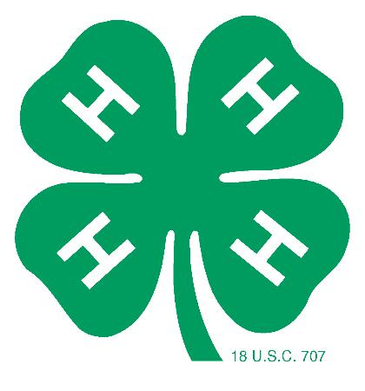

IOWA COUNTY 4-H AMBASSADOR APPLICATION

Name:

Name of Parents/Guardians:

4-H Club: Years in 4-H:

Grade Completed: Future Plans:

Youth Email: ___________________________________________ Youth Phone Number: ___________________________________

T-Shirt Size (Adult Sizing): _________________

- Why do you want to be a 4-H Ambassador?

- Briefly explain what qualifies you to be a 4-H Ambassador? How will these qualifications assist you in your Ambassador responsibilities?

- 4-H Project Overview
List your primary 4-H project involvement, the number of years you’ve been enrolled in the project, and any special achievements or honors you have received.

Project Years Enrolled in Project Project Achievements/Honors

- 4-H Leadership/Citizenship Experience
Briefly highlight your 4-H experience in the following areas:

4-H Club & County Leadership (officer roles, committees, programs, etc.)

4-H Club & County Participation (activities, events, trips, etc.)

4-H Club & County Citizenship/Community Service Involvement

I personally have prepared this application and certify that it accurately reflects my work. If selected to serve as a 4-H Ambassador, 4-H Royalty, or on the “H” Team, I fully understand my responsibilities and am committed to fulfilling them.

Applicant’s Signature: ______________________________________________________________ Date: _________________________

Interviews will be held on Monday, July 18th from 12:00pm-4:30pm. You will be notified by email of your interview time. Please state your interview time preference: ___________________________________________.
We will try our best to accommodate your request but cannot give any guarantee.

Return by July 8th, 2022 to: UW-Extension Iowa County
Attn: Tom Harman
303 W Chapel Street
Dodgeville, WI 53533
Tom.Harman@iowacounty.org
IOWA COUNTY 4-H ROYALTY AND H-TEAM APPLICATION

Name:

Name of Parents/Guardians:

4-H Club: Years in 4-H:

Grade Completed: Future Plans:

Do you wish to serve as Iowa County Royalty or on the H-Team? Yes, both ______ Only H-Team ______

Have you previously served as the Iowa County 4-H King or Queen? Yes__________ No__________

Have you previously served as one of the four H’s on the H-Team? Yes__________ No__________

- Explain what leadership qualities and values are significant to being a 4-H Ambassador.

- Why is the 4-H Ambassador program important to Iowa County 4-H?

- How have you contributed to the 4-H Ambassador program? What additional contributions will you make if selected to serve as the 4-H King/Queen or a member of the H-Team?

Return this application along with two adult recommendations to the Extension Office by July 8th, 2022.

